2020 02 20 NR Daily Log

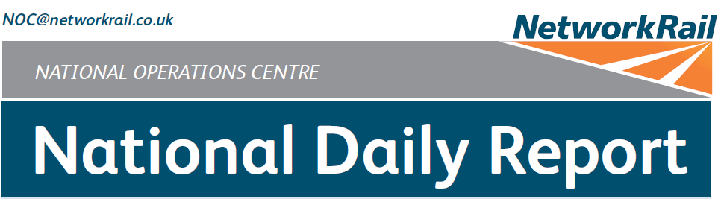



***DATE OF REPORT: NOC MANAGER 0700 – 1900:***

***NOC MANAGER 1900 – 0700:***

***DUTY CONTROLLER 0630 – 1830:***

***DUTY CONTROLLER 1830 – 0630:***

***SUPPORT CONTROLLER 0630 – 1830:***

***SUPPORT CONTROLLER 1830 – 0630:***

***LONDON CONTROLLER 0700 – 1900:***

***LONDON CONTROLLER 1900 – 0700:***

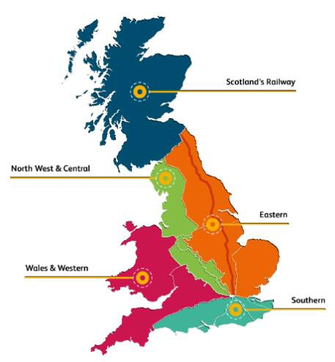

Thursday 20th February 2020 Paul Dellow

Matthew Whitfield Dominic Duggan David Wiltshire Karl Biswell Cornelius Edjah Darren Griffen Keith Stokes

Page 2 of 1

5

|  |  |  |
| --- | --- | --- |
|  | ***TABLE OF CONTENTS*** |  |
| ***01*** | ***WRONG SIDE FAILURE REPORTS*** | ***4*** |
| ***02*** | ***SIGNALS PASSED AT RED (CATEGORY ‘A’)*** | ***4*** |
| ***03*** | ***DERAILMENTS*** | ***4*** |
| ***04*** | ***COLLISIONS*** | ***4*** |
| ***05*** | ***TRAIN OR VEHICLE RUNAWAY*** | ***4*** |
| ***06*** | ***OPERATIONAL INCIDENTS*** | ***5*** |
| ***07*** | ***TRAINS WITH STRANDED PASSENGERS*** | ***5*** |
| ***08*** | ***SIGNIFICANT POSSESSION PROBLEMS*** | ***6*** |
| ***09*** | ***FATALITIES*** | ***6*** |
| ***10*** | ***INJURIES/ASSAULTS*** | ***6*** |
| ***11*** | ***NEAR MISSES*** | ***7*** |
| ***12*** | ***RAILWAY CRIME*** | ***7*** |
| ***13*** | ***STATION OVERRUNS*** | ***7*** |
| ***14*** | ***BROKEN RAILS/TRACK DEFECTS*** | ***8*** |
| ***15*** | ***POWER FAILURES*** | ***8*** |
| ***16*** | ***POINTS FAILURES*** | ***9*** |
| ***17*** | ***SIGNALS/SIGNALLING SYSTEMS FAILURES*** | ***9*** |
| ***18*** | ***TRACK CIRCUIT & AXLE COUNTER FAILURES*** | ***9*** |
| ***19*** | ***BRIDGE STRIKES*** | ***9*** |
| ***20*** | ***ROAD VEHICLE INCURSIONS (NON-LEVEL CROSSINGS)*** | ***9*** |
| ***21*** | ***TRACTION FAILURES*** | ***9*** |
| ***22*** | ***WEATHER-RELATED PROBLEMS*** |  |
| ***10*** |  |  |
| ***23*** | ***FIRES*** |  |
| ***11*** |  |  |
| ***24*** | ***WILD REPORTS & HABD ACTIVATIONS*** |  |
| ***12*** |  |  |
| ***25*** | ***GROUP STANDARDS GE/RT8250 & GO/RT3350*** |  |
| ***13*** |  |  |
| ***26***  ***14*** | ***TPWS*** |  |

***27***

***MISCELLANEOUS***

***14***

***28***

***REVIEW TABLE***

***14***

***29***

***REAL TIME PERFORMANCE FIGURES***

***15***

***01 WRONG SIDE FAILURE REPORTS***

None.

***02 SIGNALS PASSED AT RED (CATEGORY ‘A’)***

# Eastern (Anglia) – CCIL 2097982 / Fault No. 3057060

At 0741 2N16, Arriva Rail London, 0659 Stratford – Richmond passed NL1043 signal on the Down North London line at Willesden High Level at red by three metres. When questioned, the driver stated they lost concentration (group 2 cause). After consultation with Arriva Rail London, the driver was judged fit to continue and was met on arrival at Richmond.

|  |  |  |  |  |  |  |  |
| --- | --- | --- | --- | --- | --- | --- | --- |
| TRUST 796661 TEKJ | | | | | | | |
| Cancelled | 0 | Part Cancelled | 1 | Trains Delayed | 24 | Minutes | 231 |

# North West and Central (NW) – CCIL 2098260 / Fault No. 882932

At 1845, 2W13, Northern, 2W23 1731 Stalybridge – Southport, passed WW145 signal on the Down Southport line at Wigan Wallgate station at red by four coaches. When questioned, the driver stated lack of concentration (group 2 cause). After consultation with Northern Rail, the driver was judged unfit to continue and was relieved of duty at Wigan Wallgate station.

|  |  |  |  |  |  |  |  |
| --- | --- | --- | --- | --- | --- | --- | --- |
| TRUST 798268 TEDA | | | | | | | |
| Cancelled | 0 | Part Cancelled | 2 | Trains Delayed | 0 | Minutes | 0 |

***03 DERAILMENTS***

None.

***04 COLLISIONS***

None.

***05 TRAIN OR VEHICLE RUNAWAY***

None.

# North West and Central (WCMLS) – CCIL 2097863 / Fault No. 882834.

At 0418 the Engineering Supervisor working within WON 47, Item 52 Camden Junction - London Euston (Lines A, D, E & X, platforms 12-16 blocked 0010 – 0525, a West Coast South Route Business EW managed possession) reported that WM2071b points on Line X at Park Street Tunnels had been run through. Investigations revealed that 6R60, DB Cargo, 1905 Basford Hall – Euston Long Welded Rail Train, had arrived in platform 15 at 0017 and the possession was taken around the train. The Engineering Supervisor had failed to ensure that the route was correctly set for the subsequent movement of 6R60 onto line X. S&T staff were on site and reported at 0422 that they had located a damaged right-hand switch. The ODM advised at 0450 that the points had been run through at 0040 and not located by S&T until 0400. The Engineering Supervisor was relieved of duty. A Mobile Operations Manager secured the points in the Normal position at 0550 and the possession was given up at 0630. 2071a points were secured in the Reverse position with detection at 0930 to restore access to Camden C.S, leaving 2071b points secured in the reverse position without detection and banned to all movements, blocking line X. Repairs are planned for Friday night.

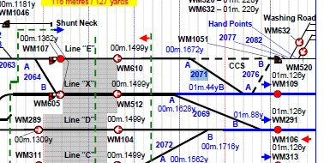

|  |  |  |  |  |  |  |  |
| --- | --- | --- | --- | --- | --- | --- | --- |
| TRUST 795959 | | | | | | | |
| Cancelled | 38 | Part Cancelled | 2 | Trains Delayed | 87 | Minutes | 787 |

# North West and Central (NW) – CCIL 2098005

At 0849 the signaller at Stockport inadvertently replaced ST2-47 signal on the Down Slow line at Stockport to red in front of 2N62, Northern, 0802 Hazel Grove – Blackpool North. The driver was unable to stop and passed the signal at red by 20 yards. The driver was fit to continue when the circumstances were explained.

# Eastern (East Coast) – CCIL 2098069

At 1120 the signaller at Barton Hill inadvertently replaced BH8 signal on the Down Scarborough line at Barton Hill to red in front of 1E29, TransPennine Express, 0854 Liverpool Lime Street - Scarborough. The driver was unable to stop and passed the signal at red by three train lengths. The driver was fit to continue when the circumstances were explained.

|  |  |  |  |  |  |  |  |
| --- | --- | --- | --- | --- | --- | --- | --- |
| TRUST 796991 CQG5 | | | | | | | |
| Cancelled | 0 | Part Cancelled | 0 | Trains Delayed | 1 | Minutes | 4 |

***07 TRAINS WITH STRANDED PASSENGERS***

|  |  |  |  |  |  |
| --- | --- | --- | --- | --- | --- |
| ***Region / Route*** | ***Train*** | ***Since*** | ***Between*** | ***OUTCOME*** | ***CCIL*** |
| NW&C (NW) | 9M48, Avanti West Coast, 0549 Glasgow Central – London Euston | 0750 –  1020 | Oxenholme and Penrith | Went forward to Oxenholme after line re-opened, following floodwater. | 2097973 |
| Eastern (East Coast) | 1E22 London North Eastern Railway 1600 Edinburgh – London King's Cross | 1855 | Doncaster – Temple Hirst | Train assisted forward at 2156 with 511 passengers on board. | 2098253 |

None.

***09 FATALITIES***

# Southern (Kent) – CCIL 2097960

At 0722 the driver of 2R07, Southeastern, 0632 Cannon Street – Ramsgate, reported seeing a body in the four foot of the Down Main line between Tonbridge and Paddock Wood. All lines were blocked, Emergency services and Network Rail staff attended at 0757. BT Police (ref. 92) reported at 0900 that having obtained a statement from the driver, they had deemed the incident an unexplained death, as the casualty showed no signs of injuries consistent with being struck by a train, and it was believed the person had fallen from a bridge. Scene of Crime Officers arrived on site to conduct their investigations, which were completed by 1041. All lines were reopened from 1053.

|  |  |  |  |  |  |  |  |
| --- | --- | --- | --- | --- | --- | --- | --- |
| TRUST 796345 XQMD | | | | | | | |
| Cancelled | 4 | Part Cancelled | 20 | Trains Delayed | 188 | Minutes | 1624 |

# Southern (Wessex) – CCIL 2098277 / Fault No. 464528

At 1918 a report from the signaller working Wimbledon panel 5 of a person walking off Vine Road CCTV

L.C. and heading in the Richmond direction, for which trains were to be cautioned, was immediately followed by the driver of 2U60, South Western Railway, 1853 Windsor & Eton Riverside – London Waterloo, making an emergency GSM-R call to report that the train had struck a person who was standing in the four-foot in the vicinity of the crossing. Both lines were blocked and traction current isolated at 2010, BT Police (Ref: 558), emergency services and Network Rail staff attended at 2011. Services were suspended between Clapham Junction and Twickenham / Staines. The BT Police reported at 2020 that having obtained a statement from the driver, they had deemed the incident a non-suspicious deliberate act. Fitters attended at 2030 and inspected the train, passing the unit fit to travel at 2050. Traction current was recharged at 2056 to allow 2U60 to move clear of the site, with an emergency switch-of taken at 2121 to allow for recovery of the remains. Undertakers arrived on site at 2100, site investigations were concluded, the remains were removed and all personnel cleared at 2142. Traction current was restored and all lines reopened from 2148. Samaritans signage and anti-trespass signs were confirmed as in place.

|  |  |  |  |  |  |  |  |
| --- | --- | --- | --- | --- | --- | --- | --- |
| TRUST 798331 XQCW | | | | | | | |
| Cancelled | 0 | Part Cancelled | 0 | Trains Delayed | 4 | Minutes | 18 |
| TRUST 798345 XQCW | | | | | | | |
| Cancelled | 44 | Part Cancelled | 13 | Trains Delayed | 106 | Minutes | 1635 |

***10 INJURIES/ASSAULTS***

# Eastern (Anglia) – CCIL 2098023

At 0953 the driver of 2U28, Arriva Rail London, 0930 London Liverpool Street – Enfield Town reported that the train had struck a person on the Down line at Silver Street. All lines were blocked, Emergency services (BT Police ref. 150) and Network Rail staff attended at 1010. Services were suspended between Seven Sisters and Enfield Town/Cheshunt. A shuttle service ran between London Liverpool Street and Seven Sisters. The person was removed alive and air-lifted to hospital by ambulance staff at 1059 after suffering life changing injuries. The lines were re-opened at 1111, with Up direction services not calling at Silver street until 1122, when normal signalling resumed.

|  |  |  |  |  |  |  |  |
| --- | --- | --- | --- | --- | --- | --- | --- |
| TRUST 796712 XQHM | | | | | | | |
| Cancelled | 26 | Part Cancelled | 10 | Trains Delayed | 11 | Minutes | 98 |

***11 NEAR MISSES***

# Southern (Wessex) – CCIL 2098225 / Fault No. 464514

At 1734 the driver of 4V39, DB Cargo, 1736 Southampton Eastern Docks – Morris Cowley M.A.T, reported a near miss at Canute L.C, Southampton, with a group of ten people who crossed 20 metres in front of the train. The driver was fit to continue. The BT Police (ref. 517) were advised. A Mobile Operations Manager and S&T attended, the crossing was tested and found to be in order at 1852.

# Scotland – CCIL 2098365

At 2353 the driver of 2G96, (ScotRail), 2324 Gourock – Glasgow Central, reported a near miss at Bishop station with an inebriated person on the Down line. The person was later observed on CCTV to have climbed back onto the platform. The driver was shaken by the incident but fit to continue. The BT Police (ref. 71) were advised.

***12 RAILWAY CRIME***

# Southern (Kent) – CCIL 2098135

At 1400 the driver of 2R40, Southeastern, 1340, Charing Cross – Dover Priory, reported a trespasser on the Down Fast line near Hither Green. BTP (ref. 292), Mobile Operations Manager and ERU attended site. The traction current was isolated at 1414 on all lines. BT Police apprehended the individual by 1438 and once all personnel were clear of the line, the traction current was restored, allowing train movements to resume at 1449. Reactionary delays and disruption continued throughout the p.m. peak.

|  |  |  |  |  |  |  |  |
| --- | --- | --- | --- | --- | --- | --- | --- |
| TRUST 797410 XQMD | | | | | | | |
| Cancelled | 39 | Part Cancelled | 79 | Trains Delayed | 507 | Minutes | 8351 |

***13 STATION OVERRUNS***

# Southern (Wessex) – CCIL 2098000

At 0834 2G92, South Western Railway, 0807 Guildford – London Waterloo formed by unit 455718, comprising eight coaches in all, overran Cobham and Stoke d’Abernon station by one coach length. The guard asked for permission to allow passengers to alight via the local door, which was agreed, and the doors were released in a controlled manner with no passenger incidents reported. The driver stated that the overrun was due to a lack of concentration. The driver was fit to continue.

|  |  |  |  |  |  |  |  |
| --- | --- | --- | --- | --- | --- | --- | --- |
| TRUST 796914 THYR | | | | | | | |
| Cancelled | 0 | Part Cancelled | 0 | Trains Delayed | 4 | Minutes | 21 |

# Southern (Sussex) – CCIL 2098273.

At 1901 1F55, Govia Thameslink Railway, 1824 Eastbourne – London Victoria, formed by units 377135 & 377162 comprising eight coaches in all, failed to call at Wivelsfield station. The driver stated that the overrun was due to being unused to approaching the station under clear signals. The driver was judged fit to continue.

|  |  |  |  |  |  |  |  |
| --- | --- | --- | --- | --- | --- | --- | --- |
| TRUST 798316 UETK | | | | | | | |
| Cancelled | 0 | Part Cancelled | 0 | Trains Delayed | 1 | Minutes | 10 |

***14 BROKEN RAILS/TRACK DEFECTS***

# Southern (Kent) – CCIL 2098105 / Fault No. 464489

At 1252 the driver of 1D58, Southeastern, 1205 Gravesend – London Charing Cross advised they heard a loud bang as they traversed Edwards Street Junction and that there was a possible track defect. As a result, the signaller did not want to run trains over the affected area and as such all traffic was held pending inspection. P’Way were sent to site and then at 1308 a service was sent through the area at extreme caution, reporting nothing amiss. Services in rear then began to proceed at caution from 1312. The driver of another passing service reported there were wet beds on the approach to TL2048 signal. P’Way staff undertook a cab ride through the area and advised at 1352 that no wet beds were visible and line speed could resume.

|  |  |  |  |  |  |  |  |
| --- | --- | --- | --- | --- | --- | --- | --- |
| TRUST 797217 IQM1 | | | | | | | |
| Cancelled | 1 | Part Cancelled | 6 | Trains Delayed | 80 | Minutes | 949 |

# North West and Central (WCMLS) – CCIL 2097858 / Fault No. 882827

At 0019 (Thu) S&T staff reported a bank slip just north of Dodford Road, No.239 bridge at Weedon (70m 20ch),.A Mobile Operations Manager was on site at 0115 and conformed that there had been movement in the bank and suggested a daylight inspection. AMEY and P/Way were on site by 0308. A 20mph ESR was imposed on the Down Fast and Down Main line, P/Way were on site with the ESR speed boards by 0434 and erected them by 0609 after having some difficulties with the diagrams.

|  |  |  |  |  |  |  |  |
| --- | --- | --- | --- | --- | --- | --- | --- |
| TRUST 795946 IQNA | | | | | | | |
| Cancelled | 0 | Part Cancelled | 0 | Trains Delayed | 288 | Minutes | 1335 |

***15 POWER FAILURES***

# Eastern (East Coast) – CCIL 2098253 / Fault No. 788526

At 1817, 1Y90, London North Eastern Railway, 1802 York – London King's Cross, came to a stand on the Up Main line south of Balne Low Gate Level Crossing, North Yorkshire after OLE section 111 had tripped at 1816 and reclosed at 1828. The driver advised that there were no issues with the train’s pantograph however, the train was only able to move forward for 5 metres and lost power. 1Y90 was authorised to proceed forward in diesel mode at 1841. At 1855 the driver of 1E22 London North Eastern Railway 1600 Edinburgh – London King's Cross with over 500 passengers on board reported that they had struck what appeared to be an OLE stanchion in the vicinity of Moss Level Crossing between Doncaster and Temple Hirst. No injuries were reported. An emergency isolation of OLE sections 111, 112, 113, and 114 was carried out and a Line Blockage of both the Up Main and Down Main lines between Joan Croft Junction and Temple Hirst taken to allow the driver to inspect the train. In the interim services were diverted via Ferrybridge and Goole where possible. OLE staff, a Mobile Operations Manager, Earthwork staff, a fitter and the BT Police (ref 553) were summoned to attend whilst an assisting locomotive was sourced from Doncaster to assist the disabled train. Following an inspection it was reported that insulators at Structure E265/18 had broken, with the cantilever damaged and hanging down from the contact wire. At 2117 the Down Main line was handed back to all traction albeit with a 50 mph ESR in place. 1E22 was on the move with assistance at 2156, 200 mins late. Single Line working was introduced on the Down Main line at 2239 after back log of trains had been cleared. Arrangements were put in place for repair work to be carried out after close of service with the possibility of reopening the line at start of service with high speed coasting in place.

|  |  |  |  |  |  |  |  |
| --- | --- | --- | --- | --- | --- | --- | --- |
| TRUST 798234 IQIE | | | | | | | |
| Cancelled | 5 | Part Cancelled | 12 | Trains Delayed | 119 | Minutes | 3322 |

***16 POINTS FAILURES***

# Wales and Western (Western) – CCIL 2098290 / Fault No. 461164

At 2005 8334 points, the Up & Down Main line crossover at Maidenhead, failed with loss of normal detection on the A end of the points, blocking the Up Main line. S&T attended at 2050 and by 2126 had secured the points in the normal position with detection maintained pending further investigations overnight. S&T staff returned to site and identified a loose terminal. The points were restored at 0144.

|  |  |  |  |  |  |  |  |
| --- | --- | --- | --- | --- | --- | --- | --- |
| TRUST 798380 IQDR | | | | | | | |
| Cancelled | 2 | Part Cancelled | 0 | Trains Delayed | 88 | Minutes | 1066 |

***17 SIGNALS/SIGNALLING SYSTEMS FAILURES***

# Wales and Western (Western) – CCIL 2097195 / Fault No. 460960, 460962

With reference to the item in this section of Monday’s Report concerning a loss of signalling following a lightning strike at Lostwithiel: Emergency Special Working was removed on the Up line at 1056 after S&T confirmed the signalling was in order.

|  |  |  |  |  |  |  |  |
| --- | --- | --- | --- | --- | --- | --- | --- |
| TRUST 791617 XQDZ (since 18/02/20) | | | | | | | |
| Cancelled | 17 | Part Cancelled | 19 | Trains Delayed | 153 | Minutes | 3560 |

***18 TRACK CIRCUIT & AXLE COUNTER FAILURES***

None.

***19 BRIDGE STRIKES***

|  |  |  |  |  |  |  |  |
| --- | --- | --- | --- | --- | --- | --- | --- |
| ***Region / Route*** | ***Time*** | ***Location*** | ***Bridge No.*** | ***Dispensation*** | ***NWR*** | ***CCIL*** | ***TRUST*** |
| Wales and Western (Western) | 0916 | Keynsham | MLN1 | DA | 0944 | 2098010 | 796714 XQDZ = 1 cape = 1 pt =  7 trains = 55 mins. |
| Eastern (N&E) | 1038 | Ecclesfield | 16 | R | 1106 | 2097945 | 796852 XQGL = 2 pt cancelled  = 37 trains = 347 mins. |
| Scotland | 2022 | Newbridge | UB1 | R | 2107 | 2098293 | 798425 XQLF = 2 cancelled = 5 pt = 77 mins |
|  |  |  |  |  |  |  |  |

***20 ROAD VEHICLE INCURSIONS (NON-LEVEL CROSSINGS)***

None.

***21 TRACTION FAILURES***

# Eastern (Anglia) – CCIL 2098289

At 2009 the driver of 4L07, GB Railfreight, 14144 Birch Coppice – Felixstowe, reported from Derby Road station that locomotive 66789 has shut down due to an oil pressure fault. An assisting locomotive was despatched from Felixstowe and attached to the front of the failed train at 2125. 4L07 departed at 2140, assisted to destination.

|  |  |  |  |  |  |  |  |
| --- | --- | --- | --- | --- | --- | --- | --- |
| TRUST 798363 MPEC | | | | | | | |
| Cancelled | 3 | Part Cancelled | 1 | Trains Delayed | 23 | Minutes | 861 |

***22 WEATHER-RELATED PROBLEMS***

# North West and Central (NW) – CCIL 2097973 / Fault No. 882851

At 0748 the driver of 1M06, Avanti West Coast, 0540 Glasgow Central – London Euston reported moving floodwater at railhead level on the Up Main line at Lambrigg, between Penrith and Oxenholme. The Up line was blocked to traffic. Passing services advised there was three flooded sites in total (21m 4ch on the Down line, 23m, 14ch on the Up line and 23m 37ch on both lines. The Down line was blocked at 0811. A Mobile Operations Manager arrived on site at 0845 to inspect the site. By 0920, the Down line had re- opened to traffic at 5 mph. By 1010 P’Way on site had inspected all the flooding sites and authorised movement at line speed.

|  |  |  |  |  |  |  |  |
| --- | --- | --- | --- | --- | --- | --- | --- |
| TRUST 796409 IQFO | | | | | | | |
| Cancelled | 4 | Part Cancelled | 36 | Trains Delayed | 151 | Minutes | 2524 |

# Wales and Western (Western) – CCIL 2098006 / Fault No. 461091

At 0855 Didcot ECR advised there had been a tripping in sections 4025 and 4026 on the Up and Down Main line between Wotton Bassett Junction and Chippenham. A passing service advised that there was a tree resting on the OLE on the Down line at signal SW1241. The Down line was blocked but the Up line remained open to traffic, once re-energised. Down direction services were diverted via Hullavington where possible. The Up Main line section, 4025, was re-energised at 0919. OLE and Off-Track staff arrived at 1013 to take a Line Blockage of both lines, remove the tree and inspect the equipment. After Off-Track staff removed the tree at 1130, it was advised the OLE had not been damaged. Staff on site further advised there were two other trees in precarious positions that needed attention. The Line Blockage was extended, and all services diverted via Hullavington, whilst two other trees were cut down. This was completed by 1218, allowing the Line Blockage to be given up, three electric traction services were observed through, all reporting nothing amiss, allowing normal signalling to resume at 1337.

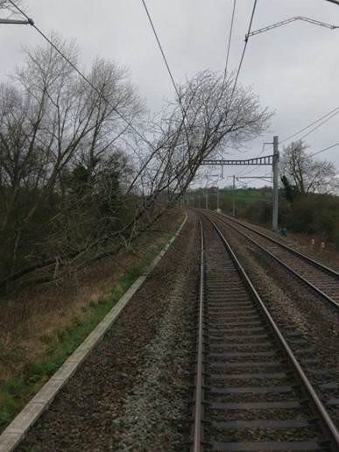 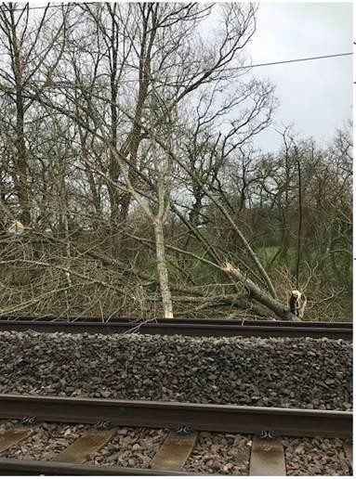

|  |  |  |  |  |  |  |  |
| --- | --- | --- | --- | --- | --- | --- | --- |
| TRUST 796627 XQDZ | | | | | | | |
| Cancelled | 6 | Part Cancelled | 0 | Trains Delayed | 49 | Minutes | 519 |

# North West and Central (NW) – CCIL 2098162 / Fault No. 882915

At 1448 the driver of 1G35, West Midlands Trains, 1431 Liverpool Lime Street – Birmingham New Street reported that whilst travelling on the Up Ditton line at Runcorn, they observed that the OLE had come down on the Down Ditton line at Runcorn. A passing service advised at 1510 that there was 30-50 metres of OLE down, with the Up line unaffected. OLE staff advised at 1606 that there was a return conductor hanging down over three to four spans at Runcorn viaduct at structure L181/16, with one dropper hanging below the contact wire. Extra staff and the required equipment were brought to site, arriving at 1708. After taking a Line Blockage of both lines, temporary repairs were completed by 1754 and the Line Blockage cancelled at 1805. Arrangements were made for staff to attend overnight to fit catenary clamps.

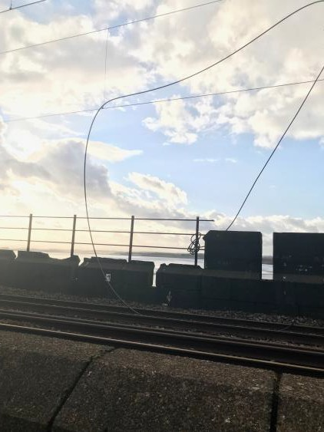 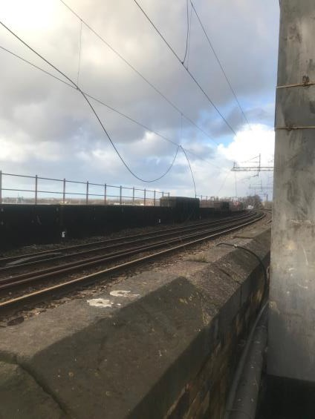

|  |  |  |  |  |  |  |  |
| --- | --- | --- | --- | --- | --- | --- | --- |
| TRUST 797511 IQFJ | | | | | | | |
| Cancelled | 5 | Part Cancelled | 27 | Trains Delayed | 58 | Minutes | 638 |

***23 FIRES***

None.

***24 WILD REPORTS & HABD ACTIVATIONS***

# Disconnected Hot Axle Box Detectors:

|  |  |  |  |  |  |  |  |  |  |
| --- | --- | --- | --- | --- | --- | --- | --- | --- | --- |
| *Region / Route* | *Location* | *Line* | *Date Disconnected* | *Reason* | *TOC’*  *s/ FOC’*  *s advis ed* | *Planned Restoration Date* | *Date Restored* | *Function* | *Fault Number* |
| Eastern (Anglia) | Brentwood | Down Electric | 10/03/16 | Offline | Y | Awaiting update |  | IM | 234632 |
| Eastern (Anglia) | Brentwood | Down Main | 10/03/16 | Offline | Y | Awaiting update |  | IM | 234632 |
| Eastern (Anglia) | Margaretting | Up Main | 19/09/19 |  | Y | Awaiting update |  | IM | 298498 |
| Eastern (EM) | Branston | Up Tamworth | 18/02/20 | Defective | Y | Awaiting update |  | IM | 154332 |
| Eastern (EM) | Chiltern Green | Down Slow | 11/07/19 | Defective | Y | Awaiting update |  |  | 148559 |
| Eastern (EM) | Napsbury | Up Fast | 11/07/19 | Defective | Y | Awaiting update |  |  | 148559 |
| Eastern (EM) | Langley Mill | Up & Down Erewash Slow | 13/02/20 | SK4 fault | Y | Awaiting update | 18/02/20 | IM | 1564199 |
| Eastern (LNE) | Barkston | Up Main | 01/04/19 | Removed for P’Way work | Y | Awaiting update |  |  |  |
| NW & Central (NW) | Bolton-le- Sands | Up Main | 25/08/19 | Integrity Fault | Y | Awaiting update |  |  | 863361 |
| NW & Central (NW) | Hest Bank | Up Main | 25/08/19 | Integrity Fault | Y | Awaiting update |  |  | 863360 |
| NW & Central (NW) | Low Mill | Down Main | 26/11/14 | Awaiting replacement | Y | Awaiting update |  | IP | 671852 |
| NW & Central (NW) | Sutton Weaver | Down Main |  |  | Y | Awaiting update |  |  |  |
| NW & Central (WCMLS) | Bradnocks Marsh (Coventry) | Up Main | 29/12/19 | Integrity | Y | Awaiting Update |  |  | 872142 |
| NW & Central (WCMLS) | Castlethorpe | Up Fast | 27/11/18 | Error code 6.0 | Y | Awaiting Update |  | IM | 832410 |
| NW & Central (WCMLS) | Harecastle | Up Main | 01/04/19 | Rail incorrectly drilled | Y | Awaiting Update |  |  |  |
| NW & Central (WCMLS) | Penkridge | Up Penkridge | 04/11/19 | Integrity | Y | Awaiting Update |  |  | 870982 |
| Wales & Western (Wales) | Dainton | Down Main | 17/11/19 | Defective PC | Y | Awaiting Update |  | IM | 453850 |
| Wales & Western (Wales) | Pembrey | Up | 17/02/20 | Constantly alarming | Y | Awaiting Update |  | IM | 460854 |
| Wales & Western (Western) | Cogload | Down Main | 25/01/20 |  | Y |  |  |  | 458740 |
| Wales & Western (Western) | Treverrin | Down Main | 01/07/19 |  | Y | Awaiting Update |  |  | 443474 |
| Wales & Western (Western) | Twerton | Down Main | 19/11/19 |  | Y | Awaiting Update |  |  | 454030 |
| Wales & Western (Western) | Warminster | Up Salisbury | 22/01/20 | Defective | Y | Awaiting Update |  |  | 458111 |

**Disconnected Wheel Impact Load Detectors:**

|  |  |  |  |  |  |  |  |  |  |
| --- | --- | --- | --- | --- | --- | --- | --- | --- | --- |
| *Region / Route* | *Location* | *Line* | *Date Disconnected* | *Reason* | *TOC’*  *s/ FOC’*  *s advis ed* | *Planned Restoration Date* | *Date Restored* | *Function* | *Fault Number* |
| Eastern (Anglia) | Brentwood | Down Electric | 10/03/16 | Offline | Y | Awaiting update |  | IM | 234632 |
| Eastern (Anglia) | Brentwood | Down Main | 10/03/16 | Offline | Y | Awaiting update |  | IM | 234632 |
| Eastern (Anglia) | Margaretting | Up Main | 19/09/19 |  | Y | Awaiting update |  | IM | 298498 |
| Eastern (EM) | Branston | Up Tamworth | 18/02/20 | Defective | Y | Awaiting update |  | IM | 154332 |
| Eastern (EM) | Chiltern Green | Down Slow | 11/07/19 | Defective | Y | Awaiting update |  |  | 148559 |
| Eastern (EM) | Napsbury | Up Fast | 11/07/19 | Defective | Y | Awaiting update |  |  | 148559 |
| Eastern (EM) | Langley Mill | Up & Down Erewash Slow | 13/02/20 | SK4 fault | Y | Awaiting update | 18/02/20 | IM | 1564199 |
| Eastern (LNE) | Barkston | Up Main | 01/04/19 | Removed for P’Way work | Y | Awaiting update |  |  |  |
| NW & Central (NW) | Bolton-le- Sands | Up Main | 25/08/19 | Integrity Fault | Y | Awaiting update |  |  | 863361 |
| NW & Central (NW) | Hest Bank | Up Main | 25/08/19 | Integrity Fault | Y | Awaiting update |  |  | 863360 |
| NW & Central (NW) | Low Mill | Down Main | 26/11/14 | Awaiting replacement | Y | Awaiting update |  | IP | 671852 |
| NW & Central (NW) | Sutton Weaver | Down Main |  |  | Y | Awaiting update |  |  |  |
| NW & Central (WCMLS) | Bradnocks Marsh (Coventry) | Up Main | 29/12/19 | Integrity | Y | Awaiting Update |  |  | 872142 |
| NW & Central (WCMLS) | Castlethorpe | Up Fast | 27/11/18 | Error code 6.0 | Y | Awaiting Update |  | IM | 832410 |
| NW & Central (WCMLS) | Harecastle | Up Main | 01/04/19 | Rail incorrectly drilled | Y | Awaiting Update |  |  |  |
| NW & Central (WCMLS) | Penkridge | Up Penkridge | 04/11/19 | Integrity | Y | Awaiting Update |  |  | 870982 |
| Wales & Western (Wales) | Dainton | Down Main | 17/11/19 | Defective PC | Y | Awaiting Update |  | IM | 453850 |
| Wales & Western (Wales) | Pembrey | Up | 17/02/20 | Constantly alarming | Y | Awaiting Update |  | IM | 460854 |
| Wales & Western (Western) | Cogload | Down Main | 25/01/20 |  | Y |  |  |  | 458740 |
| Wales & Western (Western) | Treverrin | Down Main | 01/07/19 |  | Y | Awaiting Update |  |  | 443474 |
| Wales & Western (Western) | Twerton | Down Main | 19/11/19 |  | Y | Awaiting Update |  |  | 454030 |
| Wales & Western (Western) | Warminster | Up Salisbury | 22/01/20 | Defective | Y | Awaiting Update |  |  | 458111 |

***25 GROUP STANDARDS GE/RT8250 & GO/RT3350***

None.

***26 TPWS***

|  |  |  |  |  |  |  |  |  |
| --- | --- | --- | --- | --- | --- | --- | --- | --- |
| ***Region*** | ***Route*** | ***Train*** | ***Signal/PSR/ Buffer Stop*** | ***Line/ Platform*** | ***Location*** | ***Speed (reported)*** | ***Speed (set)*** | ***CCIL*** |
| NW&C | NW | 1N88, Northern, 1437 Liverpool Lime Street – Blackpool North | PN16 signal | Down Slow | Euxton Junction | 65mph | 46mph | 2098177 |
| Scotland | Scotland | 1P13 ScotRail 1849 Edinburgh – Dunblane | EPJ517 | Down Line | Polmont | 52 | 46 | 2098274 |
| Southern | Wessex | 2G53, South Western Railway, 1803 WAT - Guildford | 40 PSR | Down Main | Guildford London Road | 60 | 63 | 2098269 |
|  |  |  |  |  |  |  |  |  |

***27 MISCELLANEOUS***

# Eastern (EM) – No CCIL Entry

At 0914 Govia Thameslink Railway advised that 9T91, Govia Thameslink Railway, 0822 Bedford – Three Bridges was delayed at London St. Pancras due to power issues on unit 700117. By 0923, the driver had overcome the issue and the service went forward, 13 minutes late.

|  |  |  |  |  |  |  |  |
| --- | --- | --- | --- | --- | --- | --- | --- |
| TRUST 796645 METR | | | | | | | |
| Cancelled | 0 | Part Cancelled | 2 | Trains Delayed | 67 | Minutes | 663 |

***28 REVIEW TABLE***

|  |  |  |
| --- | --- | --- |
| ***INCIDENT*** | ***TODAY’S TOTAL*** | ***DAYS SINCE LAST INCIDENT*** |
| **PASSENGER ACCIDENTAL FATALITIES** | **0** | **443** |
| **RAILWAY WORKFORCE FATALITIES** | **0** | **69** |
| **SIGNALS PASSED AT RED (CATEGORY ‘A’)** | **2** | **3** |
| **SIGNALS PASSED AT DANGER (ERROR/TECHNICAL SIGNAL REVERSION)** | **2** | **0** |
| **DERAILMENTS** | **0** | **13** |
| **TRAIN COLLISIONS** | **0** | **8** |
| **TRAINS STRIKING ROAD VEHICLES** | **0** | **24** |
| **ENVIRONMENTAL INCIDENTS** | **0** | **10** |

***29 REAL TIME PERFORMANCE FIGURES***

